Plaque for the late _____________________,

Please forward your wording back by mail or email to clients@gippslandmemorialpark.com

In the space below, please provide details for the wording of the plaque to be placed in the Lawn Cemetery.

1 .....................................................................................................................

2 .....................................................................................................................

3 .....................................................................................................................

4 .....................................................................................................................

5 .....................................................................................................................

6 .....................................................................................................................

7 .....................................................................................................................

8 .....................................................................................................................

9 .....................................................................................................................

10 ...................................................................................................................

If you wish to fit an Emblem or Photo please advise us when placing this application (as Extra Costs are involved). The first emblem is free of charge.

Signed……………………………..…………Date………...…......Phone…………………….………

email address... ..........................................................................................................................

Please note that items made of glass, concrete or metal; alcohol or dangerous items are not permitted to be placed in this area, and they will be removed by cemetery staff.
Flowers should be placed in vases provided and will be removed by the cemetery when they appear wilted or untidy.

Sample Lawn Plaque:

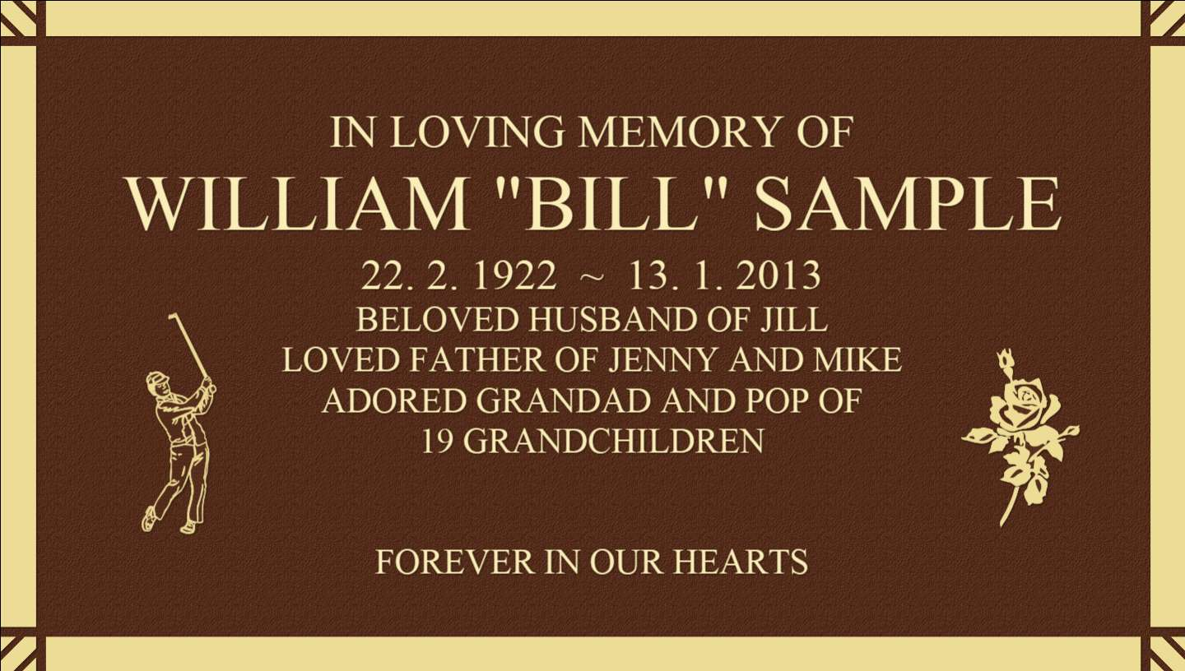

Please note:

Whilst the first emblem is included at no charge, each additional emblem is $50 each.

Photographs (ceramic ‘photo tiles’) incur a charge of $300.

